**How to create a scroll bar**

**Add items for the bar->Select all of them**

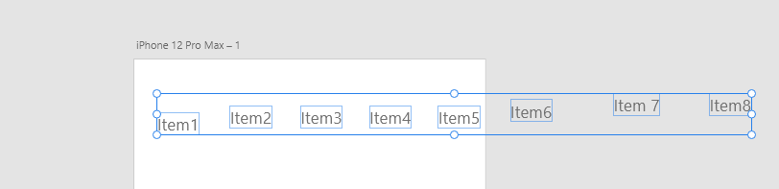

**Align those items with the icons in to top right corner**

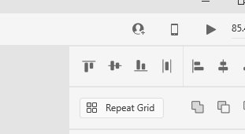

**Click the scroll icon to make the items scrollable**

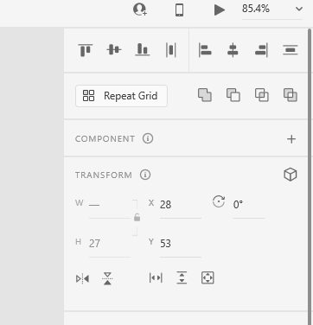

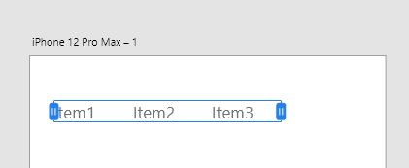

Preview to scroll vertically